Getting data into R

Setting your working directory.

* Navigate to your lab folder in explorer. Once you are here, you will need to get the path name to the folder where R will find your data or your code. The working directory is where R will default save any outputs or exports.

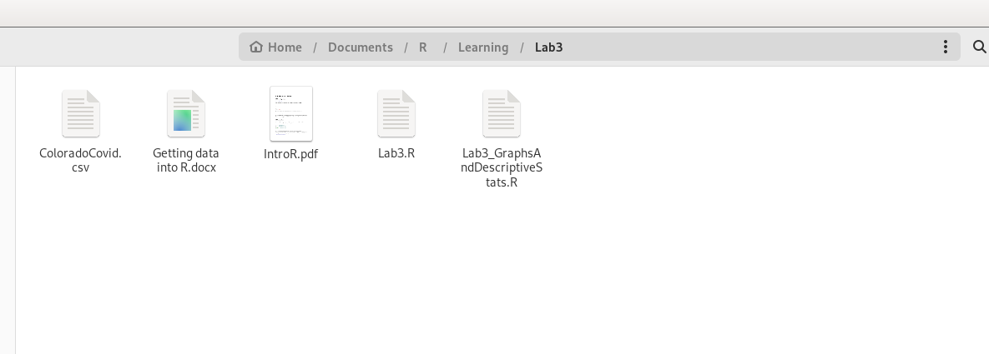

* 2. Click on the folder icon in explorer to get the full path name of this folder. You need the full path name. Copy this file path to set your working directory.
* 3. Go to R Studio. In your script, paste the file path into the set working directory function.

# set working directory

setwd('/home/admin/Documents/R/Learning/Lab 3').

In order for R to read your path name, you need to do one of three things: 1) change the direction of the forward slash to a back slash or 2) add another forward slash or 3) use a built-in read string function r”()”. All will work.

1. setwd('setwd('/home/admin/Documents/R/Learning/Lab 3').').

2. setwd('setwd('C:\\home\\admin\\Documents\\R\\Learning\\Lab 3').').

3. setwd(r"(C:\Users\Box\Labs\Lab_3)")

* 4. For your final project data, make sure to clean up any column names in the csv before bringing the data into R. R will not work well with special characters in the column names. It is best to use just text letters. Do not start a column name with a number. Always use a letter first. Use camel hump typing to name your attributes (e.g., maleWeight, femaleWeight, maleHeight, femaleHeight).
* 5. Read in your data.

##Daily COVID cases and mortalities in Colorado in Spring 2020

covid=read.csv("ColoradoCovid.csv")

With the correct set working directory, R should find your data frame with no trouble.